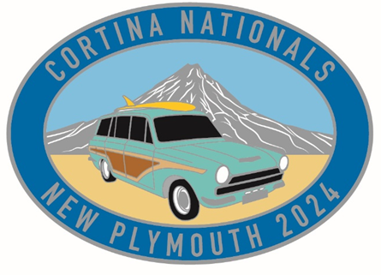

**EVENT AGENDA**

**CORTINA NATIONALS**

**25 – 28 October 2024**

**NEW PLYMOUTH**

**Friday 25th October**

Registration night

Meet and greet Plymouth International Hotel

**Saturday 26th October**

Show and Shine, East End Reserve, New Plymouth

Run along spectacular southwest coast for lunch

After lunch, car run around the mountain via a shed visit in Stratford/Inglewood.

Sat night shindig with a band, Plymouth International Hotel

**Sunday 27th October**

Meet at New Plymouth Raceway for car run

Car run along some spectacular local scenic roads to lunch, which is at a private car collection.

After lunch will return via some more local scenic roads.

Evening formal function at the Plymouth International will include prize giving, auction

**Monday 28th October**

Breakfast at The Hideaway (Holden Museum)